**configMaps:**

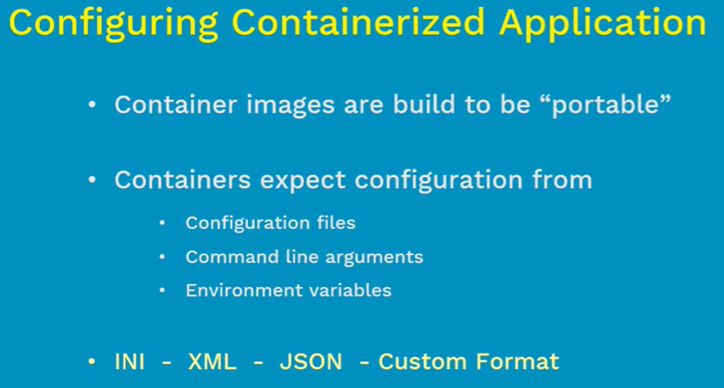

* Configmap is a Kubernetes object which allows us to separate the configuration from pods and components
* It makes the containers portable and easy to manage the configurations. And prevents the hardcoded data in pods.
* We need to use secrets if there is any sensitive data.

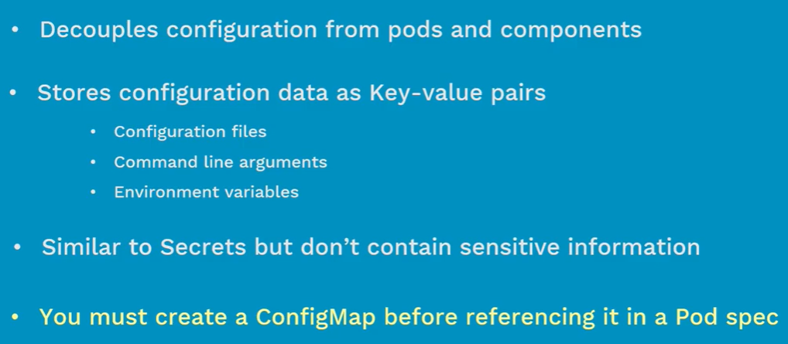

* If we add configmap to the pod and the configmap doesn’t exist, then POD won’t get started.

**Creating configmaps using directories:**

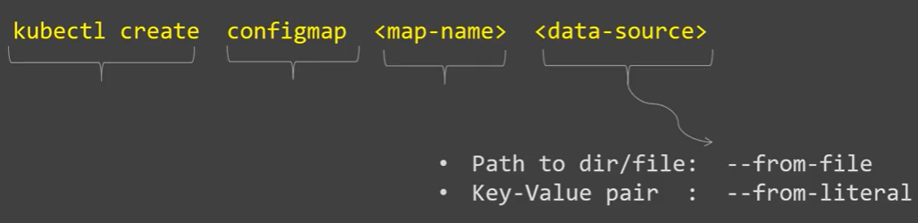

* Let’s say we have key value pairs in files as below.

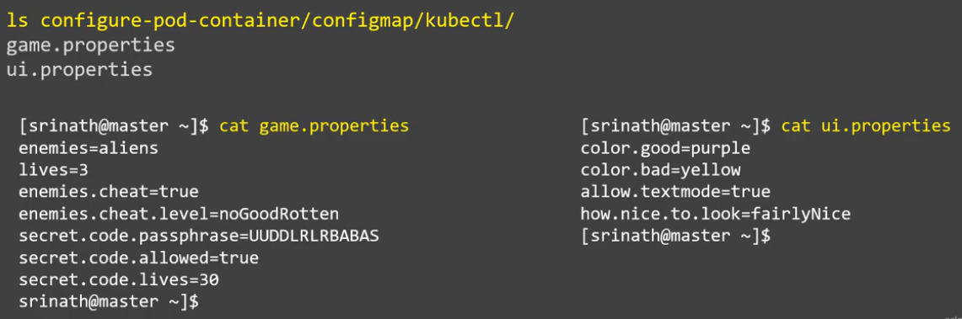

* Now, we can create configmap from file option by giving the directory name in command as below.

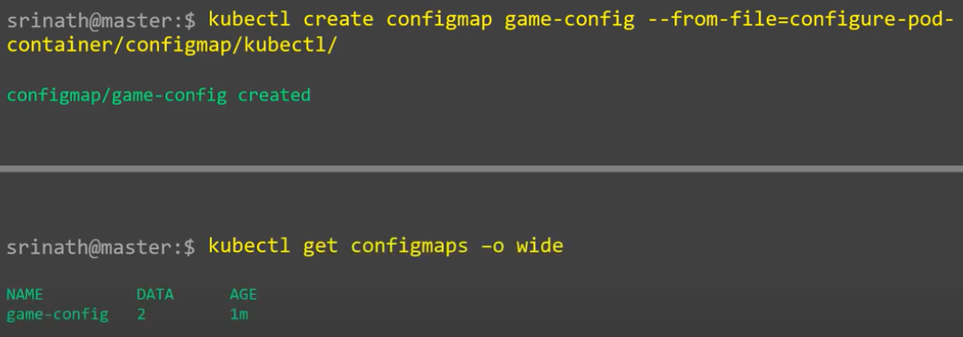

* We can see that yaml file from get configmaps option below as it got created with both the files inside the directory.

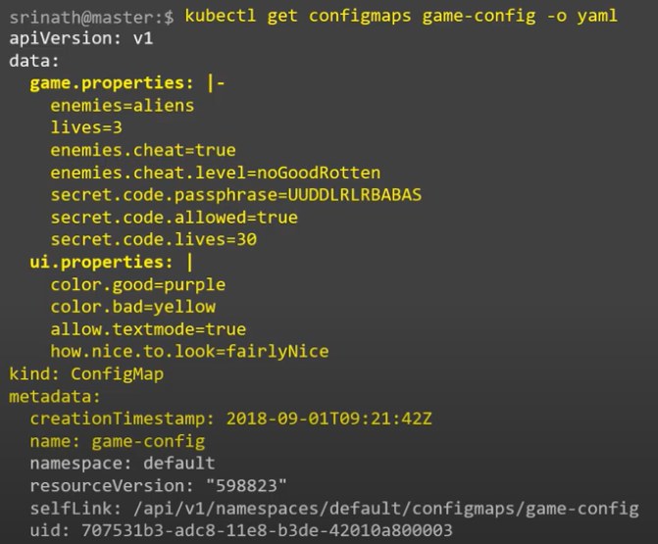

**Creating using files:**

We can create it using same file from option as below.

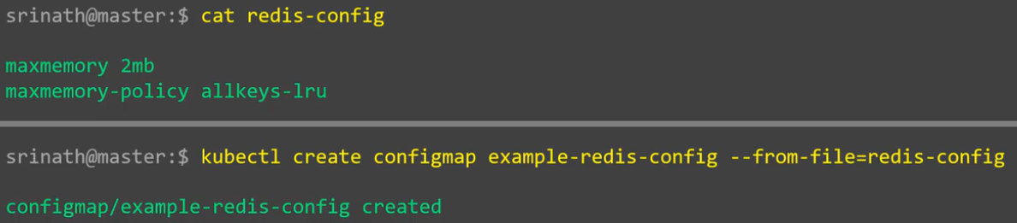

If we want to create configmaps from multiple file or directories, then use below command.

* **Kubectl create configmap <name> --from-file=file1 –from-file=file2**

**Creating configmaps from literal values:**

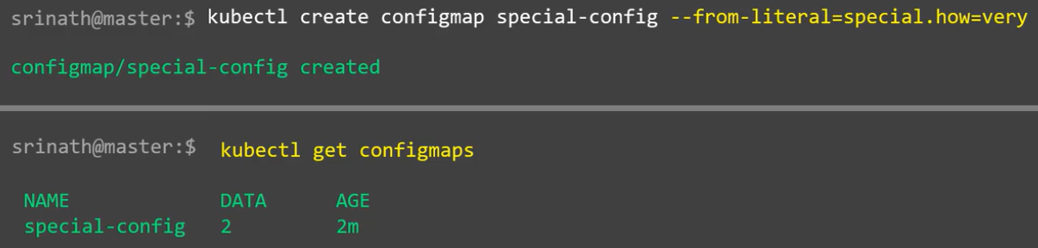

We can also create with multiple key as below.

* **Kubectl create configmap <name> --from-literal=<key>=<value> --from-literal=<key>=<value>**

**Configmaps in pods volumes:**

* We can add configmap as a volume in POD as below.
* When we create configmap with **“—file-from”** option, the file name becomes the key and the content of file becomes the value.
* So, when we give filename as **“key”** in below yaml file, the data from that file will be added to the **“redis.conf”** file inside the given mount path

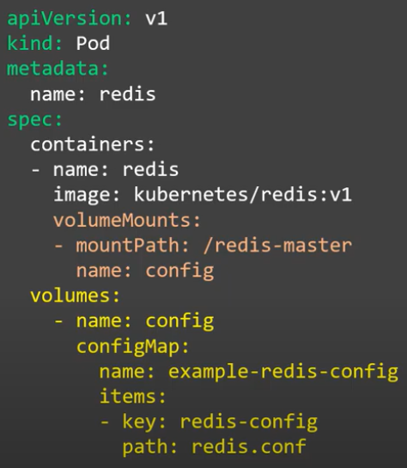

* If we don’t give the path or key. It will take all the files from configmap to the mount path.

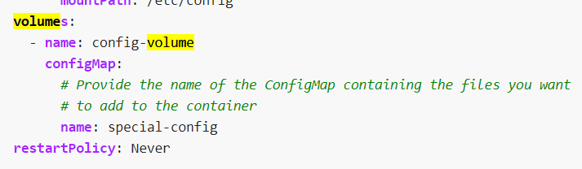

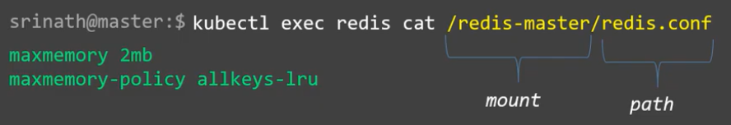

* We can also add as below.

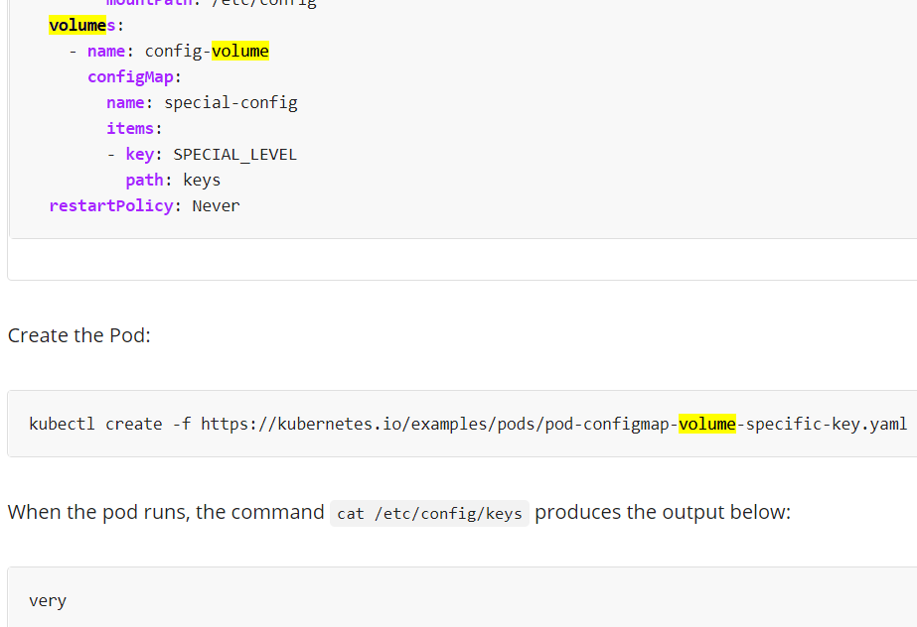

* As above, if there is any date already present in “/etc/config” will be deleted.

**Configmap as environment variable in POD:**

* Now, we can configure that configmap as environment variable in POD.

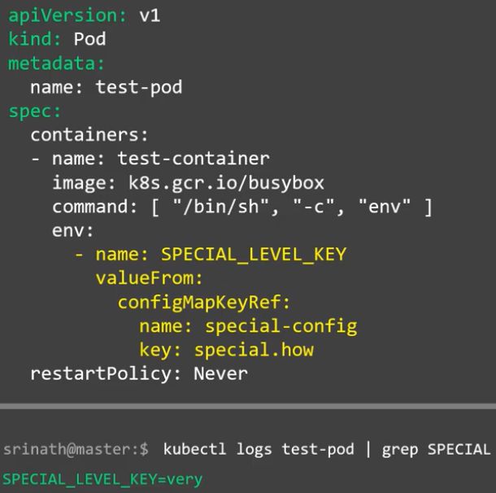

* As above, we are creating environment variable **“SPECIAL_LEVEL_KEY”** by taking the key **“special.how”** from **“special-config”** configmap.
* We can create from multiple containers as below.

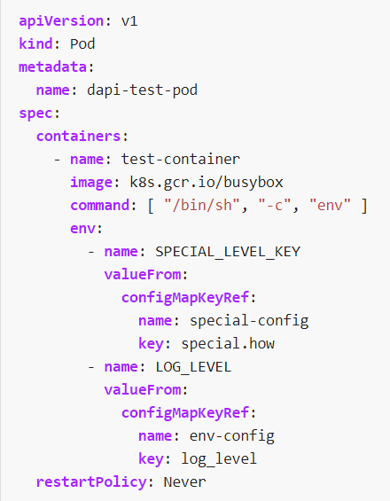

**POD configuration with all the keys from configmap:**

* If we want to configure few keys from configmaps. Then we need to use key option in yaml file by changing the env name.
* But if we want to add all the keys of configmaps to the POD. We can mention like below with **“envFrom”** option simply.

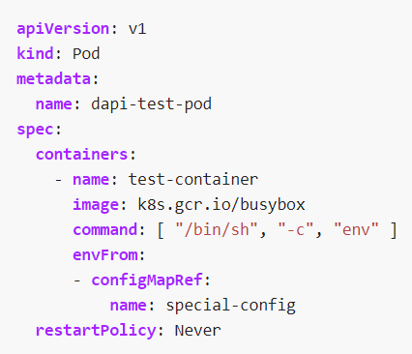

**Simple way:**

* We can create configmap yaml file with all the key values as below.

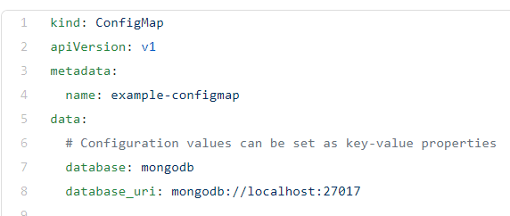

* And we can add that to the POD as a volume of environment variable.

